Setting up a ChatGPT Bot

These instructions are for setting up a ChatGPT bot to process and respond to messages sent to it by submitting that request to OpenAI/ChatGPT. This only works on Windows.
Ideally you will run this from either a separate PC or in a virtualized Windows environment that has your bot logged into Twitch. The reason being is that when you run the program it will authenticate the bot account against Twitch. It will default to the current Twitch account that’s logged in. That account needs to be the account that’s registered as a bot (performed in steps 1 and 2). If you were to do this on your main PC with your main account, it would attempt to authenticate against your main account and would not function.

1. Create Twitch bot
You need a Twitch account that will have viewers direct messages/requests to. This bot will then respond to messages.
If you don’t have one, create a bot account by sign out of your main Twitch account. Alternatively, open a Private/Incognito Mode to create an account. Remember these login credentials!

2. Register your Twitch bot as an application.
While logged in to your bot’s Twitch account, go to https://dev.twitch.tv/console

Select “Register Your Application” in the top-right.

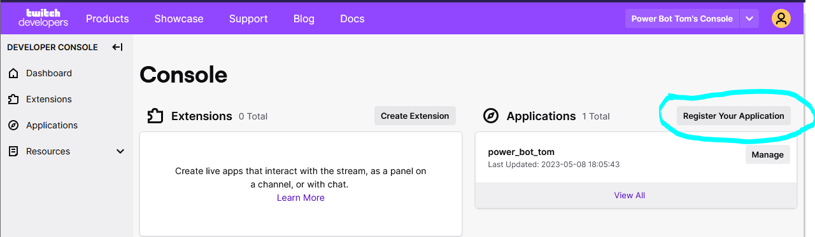
Fill out the application as follows:
Name: ChatGPT
Oauth Redirect URLs: http://localhost:17563
Category: Chat Bot

Select “Create”
This will take you to you to a page showing your registered apps that can use the Twitch API.
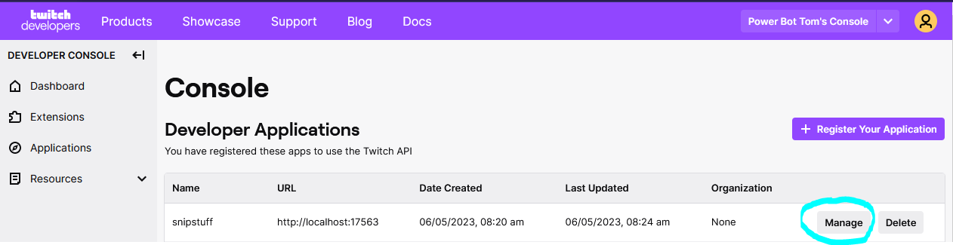

Select “Manage”
Write down/save the Client ID as your Twitch App ID.
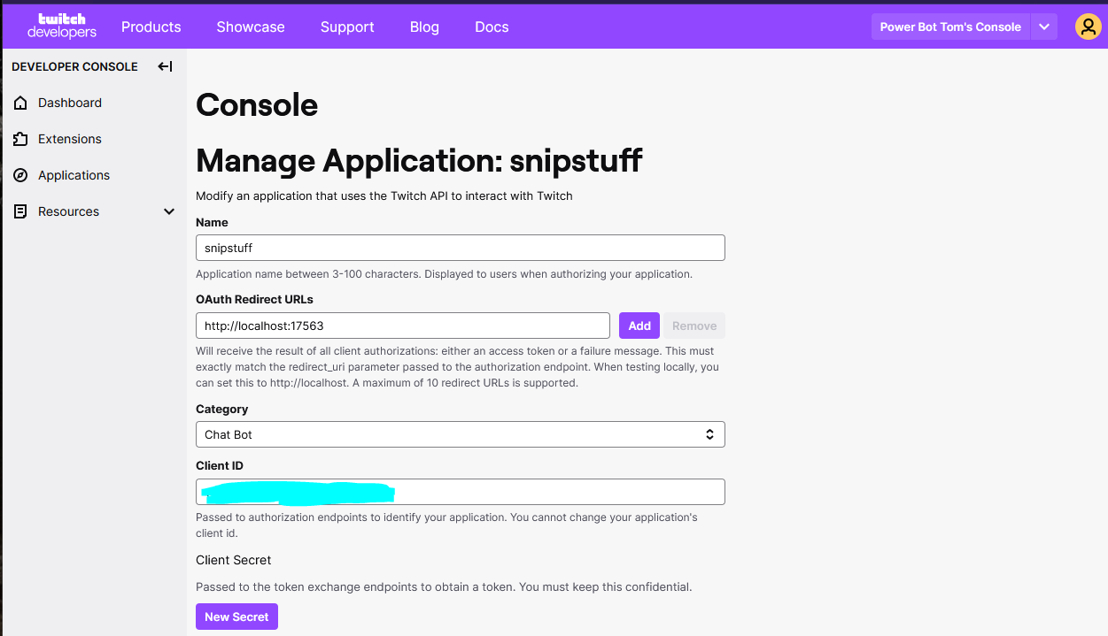

Select “New Secret”
You will be asked if you want to generate a new secret. Select “OK” or “Yes”.
An alphanumeric value will appear above the “New Secret” button. Write down/save this as your Twitch App Secret.

3. Create OpenAI Account
OpenAI is the service that processes the message requests and returns the AI-generated response. The first time you sign up, you get a credit for free usage that expires after 2 months. Afterwards, you will need to add a billing method to pay for the service. It is a usage-based service, so if you don’t use it you’re not charged anything. The amount charged is based on the “tokens” used which loosely correlates to the size of the response. This can be a thousandth of a penny but over time can add up. I would expect it to cost roughly less than $2/month and can likely cost less than $1/month depending on usage.
Go to https://platform.openai.com/signup?launch and sign up for an account. You will need to validate a phone number with their service.
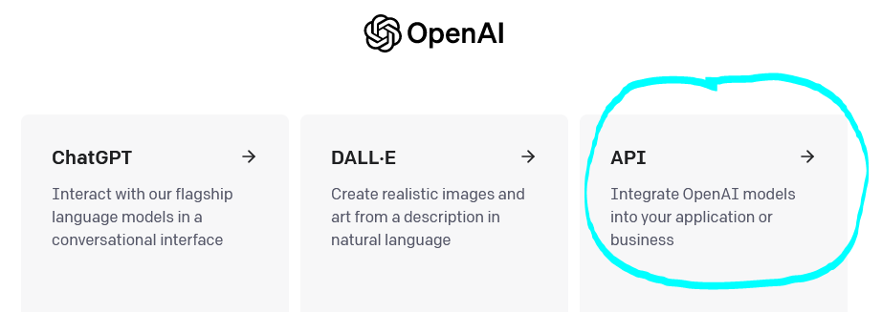
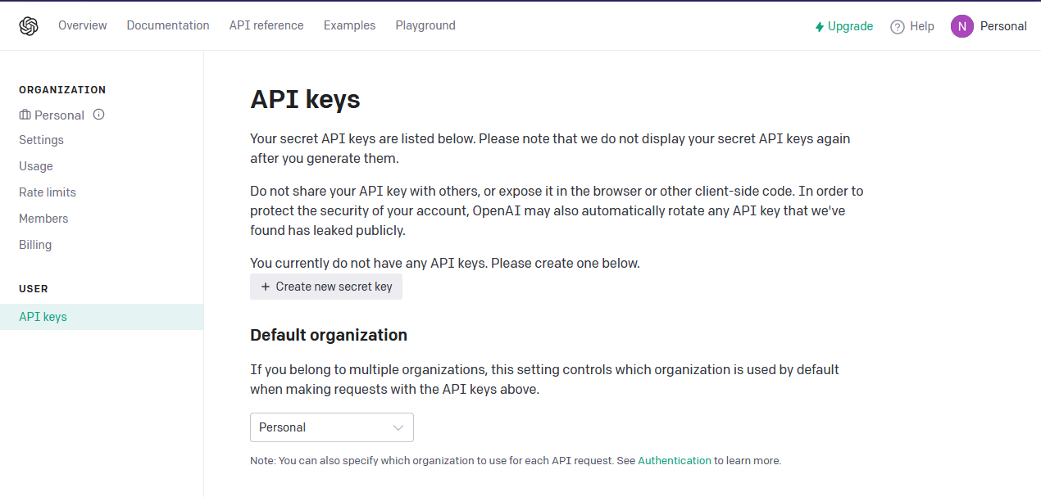
After verifying your phone number, you will be asked which platform you want to use. Select API.
Select your account menu in the top-right and select “View API Keys”.

Select “Create new secret key”
Give the key a name (e.g. ChatGPT) and select “Create secret key”
An alphanumeric (with special characters) value will appear. Write down/save this as your OpenAI secret key.
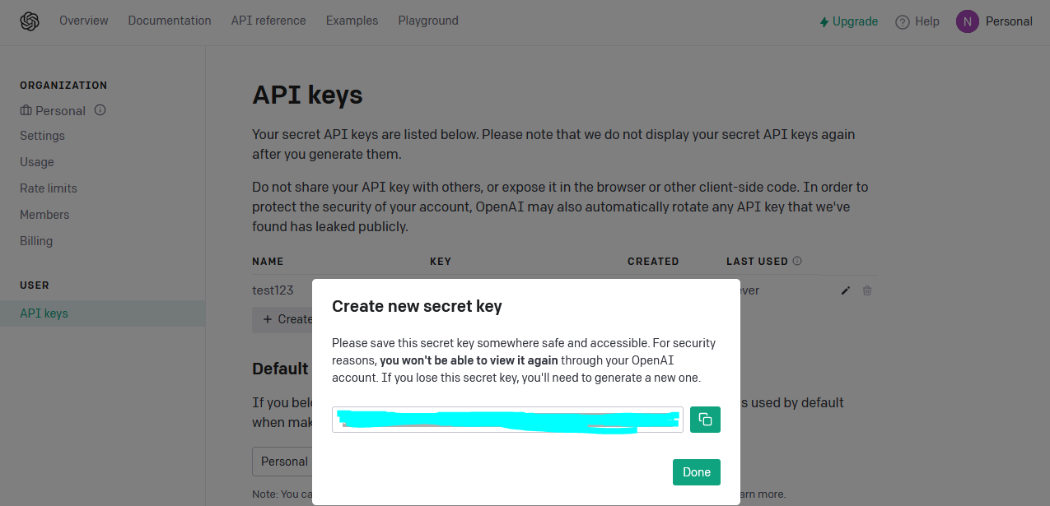
This secret key will not be viewable again. If you forget or lose the secret key, you will need to delete the old key and make a new one.

4. Install Microsoft VS Studio
This is the program that will need to remain open and running a file introduced later on in the instructions. You can have it running on any machine, it doesn’t need to be running on your stream PC.
Go to https://code.visualstudio.com/ and download the appropriate build. After download is complete, fully install VS Studio. When prompted, open VS Studio. It should look something like this.
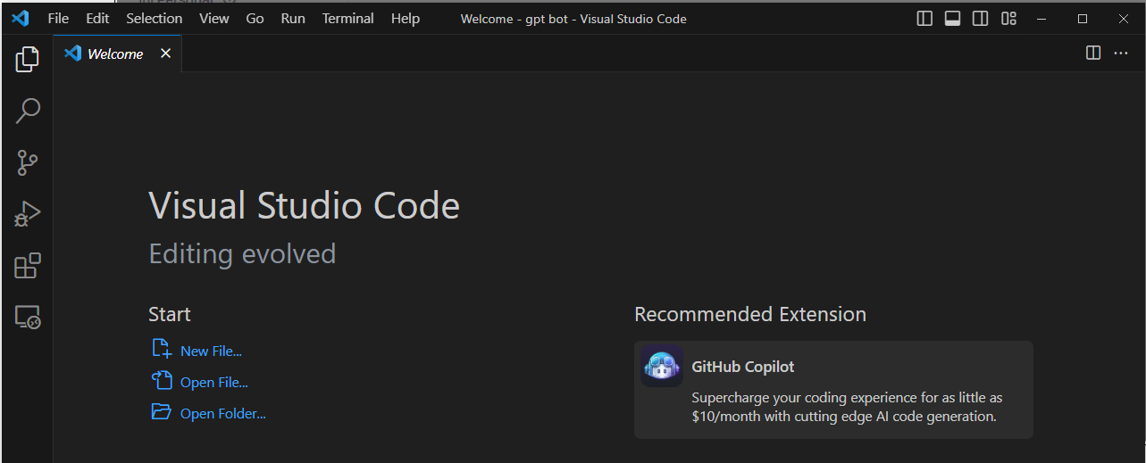

5. Install Python extension for VS Studio
The code that will be run uses Python, a programming language. VS Studio is a barebones development environment and needs an extension to know and process Python code.
Go to https://marketplace.visualstudio.com/items?itemName=ms-python.python and select the Install button. This should redirect you to VS Studio. A blue “Install” button should appear towards the top of the screen.

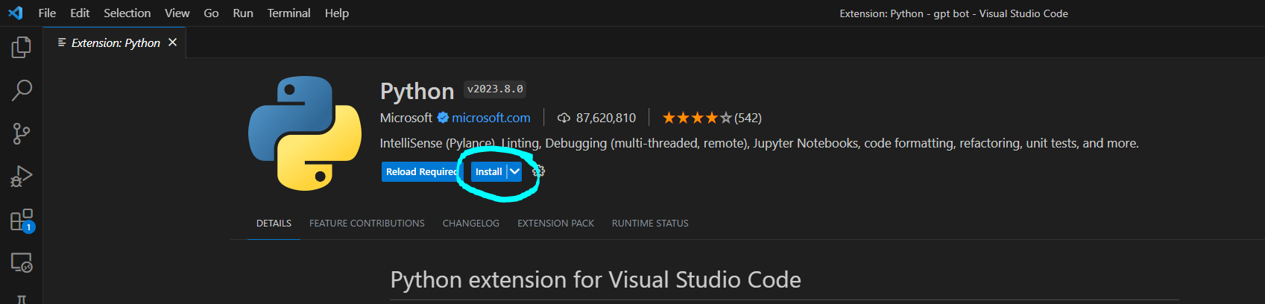
6. Install additional Python Libraries
Python uses “Libraries” as a way to easily reuse code. You need to install 3 libraries; twitchapi, asyncio, and openai. To do this, open Windows PowerShell as an administrator on the PC that will be running the bot. This program comes standard with Microsoft Windows. When opened, it should look like this.
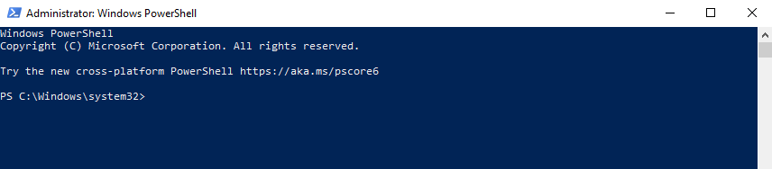
You will need to install these one at a time. Type each of these lines one at a time, hit enter, and wait for the installation to be complete before installing the next library.
pip install asyncio
pip install twitchapi
pip install openai

Once all 3 libraries are installed, you can close Windows PowerShell.

7. Download Python files
There are four files that will be used. You can download them at this link.
https://github.com/snipunGPT/Twitch-ChatGPT/archive/refs/heads/main.zip
Unzip to a folder on the PC that will be running the bot.

ChatGPT.py
This is the main file. Once configured and run, the file will have your Bot join your channel and wait for chat messages that are directed at the bot’s name (e.g. “@botname what is 2+2). The bot will then query OpenAI and respond.
The bot is told to “Pretend you have the personality of a <identity> and reply to <prompt>”. The chat message is the “prompt” while the “identity” is set in another file.
Keep in mind that if the response is greater than 500 characters, a response will not be given in Twitch. This 500 character limit is a Twitch limitation. There are ways around this but effectively would mean a 999 character response would be broken into 2 messages which could seem very spammy.

Config.py
This is where you will enter your Twitch API ID and Twitch API Secret Key.

Credentials.py
This is where you will enter your OpenAI Secret Key.

Personality.txt
This is where you identify the personality that the bot should assume when responding. Keep in mind that OpenAI has policies in place to return a response notifying you that its own response would have broken those policies. For example, if your personality is “raging alcoholic” it will likely not respond to even the simplest prompt as it would promote abuse of alcohol. Additionally, the prompts themselves may break policy, such as asking it to give directions on how to hack a computer.
Since the bot is told to “Pretend you have the personality of a <identity> and reply to <prompt>”, make sure the text in the personality.txt file makes sense with the sentence structure. If you used “a crafter” then there would be two “a”s. Instead, you would want to just use “crafter”.
The personality.txt file can be updated while the bot is live. However, note that there is a few seconds delay between when that’s changed and when the bot detects that change.

8. Configure Python files

Organizing your VS Studio Workspace
Go to Visual Studio.
Select “File”
Select “Add Folder to Workspace” and select the folder where the Python files were unzipped to.
You should see something like this.
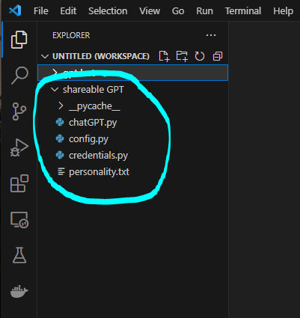

config.py
Select the “config.py” file.
Replace the APP_ID variable with your Twitch App ID. Keep an apostrophe on both sides of the value.
Replace the APP_SECRET variable with your Twitch Secret Key. Keep an apostrophe on both sides of the value.
It should look something like this. Save the file (ctrl-s) or access File → Save.
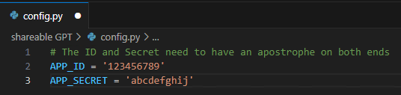
Close the file out. It does not need to be kept open.

credentials.py
Select the “credentials.py” file.
Replace the MY_API_KEY variable with your OpenAI Secret Key. Keep an apostrophe on both sides of the value.
It should look something like this. Save the file (ctrl-s) or access File → Save.
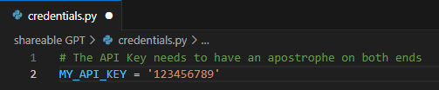
Close the file out. It does not need to be kept open.

chatGPT.py
You need to identify your channel name and the name of your bot.
Select the “chatGPT.py” file.

Channel Name
Go to Line 66.
Replace the indicated text with your channel name, NOT the URL. Keep an apostrophe on both sides of the value.

Bot Name
Go to Line 68.
Replace the indicated text with your channel name, NOT the URL. Keep an apostrophe on both sides of the value

personality.txt
This is where you identify the personality. By default, it’s set as “priest who thinks Jeff Bezos is God”. You can change this to whatever you want, but be aware of its limitations (see sections above).
You can change this on the fly while the bot is live but may take a few seconds to update. You could also have this linked to a channel redemption or command to update from Chat (e.g. a command built to update the text of a file) but again can take a few moments for the chatbot to recognize the change.

9. Starting the ChatGPT Bot
Open chatGPT.py file. It is important you do this with your bot account logged into Twitch. This has to be done every time you start the bot. Again, it’s ideal for it to be done on a second PC or inside a virtualized environment to keep your accounts separate.
Select the Run Python File icon in the top-right.
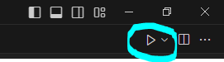
This sometimes needs to be hit a few times. What you’re looking for is the Terminal text in the bottom to show some yellow and blue text indicating it’s been run.
You are also needing a web browser to pop up and authenticate your account. The first time you run this on a PC it will prompt you to authorize the appt to use your Twitch account. Subsequent times it will just take you straight to a webpage showing oauth has been performed.
This is what the webpage will show if the bot is up and running.
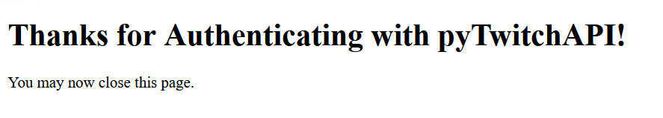
You will see any text messages entered in your channel now appear in Visual Studio’s Terminal.
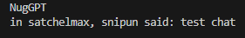
All executions of the bot will appear below the prompt and indicate it’s responding to a convo with the username.

